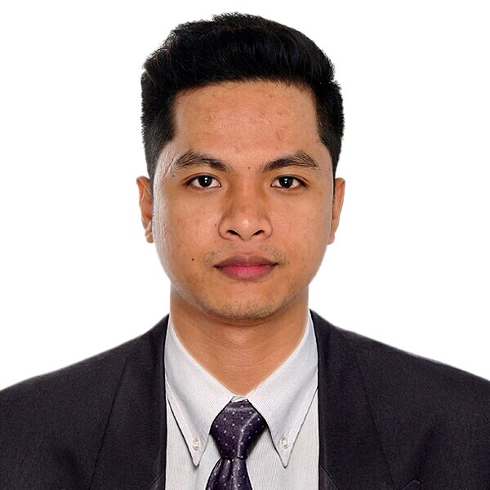
HERBERT F. MENDOZA
Blk 293C Bukit Batok St. 21 #40-530
Singapore 653293
herbertfmendoza@gmail.com
+65 8650 7118

Professional Profile
Highly motivated Warehouse Operations Supervisor with much enthusiasm to learn more for continuous career growth and improvement. Previously an Accounts Receivable & Insurance Claims Specialist with more than 5 years of working experience in Dental billing processes; 1 year and 5 months as Corporate Marketing Assistant; and with extensive training experiences in administration, documents & inventory control.

Qualifications
- Working knowledge in warehouse operations | - Dentrix & Remote lite software
- Reach truck operation | - Computer literate
- Data entry, documents & inventory control | - Good written & oral communication skills
- Good attention to details | - Active listener & team-oriented
- Insurance claim processes & policies | - Ability to adapt to changes
- Basic insurance accounting knowledge | - Degree in Business Administration

Work Experiences
Warehouse Operations Supervisor
TRIA Pte. Ltd. | Singapore
January 2020 - Present
Responsibilities:
- Supervising warehouse and daily activities.
- Tracking and maintaining right inventory levels.
- Maintaining records, reporting relevant information, and preparing any necessary documentation e.g preparing DOs.
- Preparing orders and dispatch outgoing goods and ensure timely delivery of goods.
- Accurately sort, label and store goods to optimize warehouse space.
- Communicating and coordinating with other departments and customers.

Accounts Receivable & Insurance Claims Specialist
Staff Virtual | Makati City Metro Manila, Philippines
January 2018 – July 2019
Responsibilities:
Execution of Claim Cycle
- Review clinical notes to ensure correct allocation of procedures and payments to providers.
- Claim submission with detailed photos, radiographs, and clinical narratives to clearinghouse
- Post insurance payments and adjustments.
- Prepare patient statements for charges not covered by insurance.
- Follow up with secondary claims, claim denials, and claims requiring additional information.
Patient Ledger Audit and Update
- Audit patient ledger for accuracy in posted payments and adjustments.
- Descriptive notes on ledger to communicate origin of balance.
- Report number of claims submitted daily, number of claims appealed, claim errors corrected, AR levels, and monthly production and collection ratios to practices.
- Update patient ledgers upon follow up of claim inquiries.
Payment Collection Processes
- Manage AR report to follow up on outstanding patient and insurance aging.
- Process weekly statements.
- Issue series of collection letters and phone calls.

Dental Billing Specialist
Cambe Dental Billing Services Inc. | Pasig City Metro Manila, Philippines
March 2014 – January 2018
Responsibilities:
- Processing dental billing services and entering data using dental software.
- Evaluating rendered dental services.
- Sending claims to the appointed insurance company to process the payment using Remote lite software.
- Reviewing and re-processing denied claims.
- Conducting dental billing services training to new staffs.

Corporate Marketing Assistant
PLDT ALPHA Enterprise | Makati City Metro Manila, Philippines
July 2012 – December 2013
Responsibilities:
- Coordinating and assisting Marketing Department in corporate and promotional events.
- Preparing logistics for corporate events.
- Preparing event agenda, invitations, registration forms for customer events.

On-the-job Training: Admin Assistant
Business Development/Special Project (Globe Innove)
Engineering & Development Corporation of the Philippines
Mandaluyong City Metro Manila, Philippines
December 2011- February 2012

On-the-job Training: Admin Assistant
Documents and Inventory Control Department
DMCI Homes Corporate Center
Makati City Metro Manila, Philippines
June 2011- September 2011

Education
Bachelor of Science | 2012
Business Administration Major in Management | Mandaluyong City Metro Manila
Rizal Technological University | Philippines

Personal Background
Nickname:  Birth date:  Gender:  Citizenship:  Weight:  Height: | Herbert  August 16, 1990  Male  Filipino  143 lbs.  5’8 ft.

